COMPUTER NETWORKS, ASSIGNMENT II
Name: Syed Sultan Ahmed, Roll No: 24K-0585, Section: BCS-5H

1. Approach and Implementation
I wrote a discrete-event simulator in Python (rdt_sim.py) without any reliable-transport library. It keeps a virtual clock and a queue of future events (packet arrival, ACK arrival, timer expiry). A hand-written channel applies loss, corruption (one flipped bit) and extra delay independently to data packets and ACKs. Corruption is detected with a 16-bit Internet checksum. Sequence numbers on the wire are i mod 2^{k}. The program rejects windows that break the sequence-number rule (GBN: N ≤ 2^{k} − 1, SR: N ≤ 2^{(k−1)}).
GBN: The sender keeps base and nextseqnum, a window [base, base+N−1], and one timer for the oldest unACKed packet. ACKs are cumulative, and on timeout it resends every packet from base to nextseqnum−1. The receiver keeps only expectedseqnum, discards out-of-order packets, and re-ACKs the last in-order packet.
SR: The sender keeps send_base and a timer per packet, and an ACK marks only that packet. On timeout only that packet is resent. The receiver keeps rcv_base and a window of size N, buffers out-of-order packets, ACKs every correct packet individually, and delivers to the application in order.
Assumptions:
- R = 2 Mbps, RTT = 500 ms (250 ms each way), L = 8000 bits, so L/R = 4 ms.
- Timeout = 600 ms, which is more than RTT + L/R = 504 ms.
- Extra delay is uniform between 50 and 300 ms.
- The link is a single FIFO path (a delayed packet holds up those behind it, no overtaking).
- ACKs are tiny, with no transmission time.
- The GBN timer restarts when the base advances.
- A corrupted data packet is discarded (GBN re-ACKs, SR sends nothing).

2. Task 1
1. Why reliable transfer is important: The messages are casualty lists, supply requests and rescue assignments, so a lost or corrupted packet could send a team to the wrong location. The satellite link loses, corrupts and delays packets and ACKs, so the transport layer must guarantee correct, in-order delivery using checksums, ACKs, retransmission and sequence numbers.
2. Why Stop-and-Wait is inefficient: It sends one 4 ms packet and then idles for the 500 ms RTT, so U = 4/504 = 0.79%. Over 99% of the link is wasted.
3. Why pipelining helps: The sender keeps N packets in flight and uses the waiting time to send more. With N = 4 utilization is about 3.17%, four times better.
4. GBN or SR: SR is more suitable.
- Fewer retransmissions: SR resends only the lost packet, while GBN resends the whole window, which wastes scarce bandwidth on a lossy link.
- Buffering and individual ACKs: The SR receiver buffers out-of-order packets and ACKs each one, so fewer retransmissions are triggered and data is still delivered in order.

3. Task 2: Packet trace (N = 4, packet 2 lost)
Assumption: ACK 0 and ACK 1 slide the window, so pkt 4 and pkt 5 are also sent before pkt 2's timer expires and arrives intact.
(a) Go-Back-N
Event | Sender | Packet | Receiver | ACK | Window
1 | Send pkt 0 | 0 | - | - | [0-3]
2 | Send pkt 1 | 1 | - | - | [0-3]
3 | Send pkt 2 | 2 (lost) | - | - | [0-3]
4 | Send pkt 3 | 3 | - | - | [0-3]
5 | - | 0 | In order, deliver; expectedseqnum=1 | ACK 0 | [0-3]
6 | - | 1 | In order, deliver; expectedseqnum=2 | ACK 1 | [0-3]
7 | - | 3 | Out of order, discard | ACK 1 (dup) | [0-3]
8 | Recv ACK 0, base=1, send pkt 4 | 4 | - | - | [1-4]
9 | Recv ACK 1, base=2, send pkt 5 | 5 | - | - | [2-5]
10 | Recv dup ACK 1, ignored | - | - | - | [2-5]
11 | - | 4, 5 | Out of order, discarded | ACK 1, ACK 1 | [2-5]
12 | Timeout (oldest unACKed is pkt 2): resend 2, 3, 4, 5 | 2, 3, 4, 5 | - | - | [2-5]
13 | - | 2, 3, 4, 5 | All in order, delivered; expectedseqnum=6 | ACK 2, 3, 4, 5 | [2-5]
14 | Cumulative ACKs move base to 3, 4, 5, 6; send pkt 6, 7, 8, 9 | 6, 7, 8, 9 | - | - | [3-6] to [6-9]
15 | - | 6, 7, 8, 9 | In order, delivered; expectedseqnum=10 | ACK 6, 7, 8, 9 | [6-9]
16 | Recv ACK 6 to 9, base=10, done | - | - | - | [10-13]
(b) Selective Repeat (S = sender window, R = receiver window)
Event | Sender | Packet | Receiver | ACK | Window
1-2 | Send pkt 0, 1 | 0, 1 | - | - | S[0-3]
3 | Send pkt 2 | 2 (lost) | - | - | S[0-3]
4 | Send pkt 3 | 3 | - | - | S[0-3]
5 | - | 0 | Accept, deliver; rcv_base=1 | ACK 0 | R[1-4]
6 | - | 1 | Accept, deliver; rcv_base=2 | ACK 1 | R[2-5]
7 | - | 3 | Out of order, buffer | ACK 3 | R[2-5]
8 | Recv ACK 0, send_base=1, send pkt 4 | 4 | - | - | S[1-4]
9 | Recv ACK 1, send_base=2, send pkt 5 | 5 | - | - | S[2-5]
10 | Recv ACK 3, mark 3 ACKed (base stays 2) | - | - | - | S[2-5]
11 | Timeout for pkt 2 only, retransmit pkt 2 | 2 | - | - | S[2-5]
12 | - | 4, 5 | Out of order, buffer both | ACK 4, 5 | R[2-5]
13 | - | 2 (retx) | Deliver 2, 3, 4, 5; rcv_base=6 | ACK 2 | R[6-9]
14 | Recv ACK 4, 5, then ACK 2: send_base=6; send pkt 6, 7, 8, 9 | 6, 7, 8, 9 | - | - | S[6-9]
15 | - | 6, 7, 8, 9 | Accept, deliver; rcv_base=10 | ACK 6, 7, 8, 9 | R[10-13]
16 | Recv ACK 6 to 9, send_base=10, done | - | - | - | S[10-13]
Answer: GBN retransmits 4 packets (2, 3, 4, 5) and SR retransmits 1 packet (2). The GBN receiver has no buffer: it discarded 3, 4 and 5 and could only ACK pkt 1, so the sender had to go back and resend everything from pkt 2. The SR receiver buffered 3, 4 and 5 and ACKed each, so only pkt 2 was missing.

4. Tasks 3 and 4: Experiments
200 packets, N = 4, k = 3, seed 585. A = reliable, B = loss 0.10, C = loss 0.05 + corruption 0.05 + delay 0.10.
Scenario | Protocol | Transmitted | Retransmissions | Delivered | Time (s) | Throughput (kbps)
A: Reliable | GBN | 200 | 0 | 200/200 | 25.21 | 63.5
A: Reliable | SR | 200 | 0 | 200/200 | 25.21 | 63.5
B: Loss 0.10 | GBN | 314 | 114 | 200/200 | 48.82 | 32.8
B: Loss 0.10 | SR | 255 | 55 | 200/200 | 41.38 | 38.7
C: Mixed | GBN | 320 | 120 | 200/200 | 47.23 | 33.9
C: Mixed | SR | 305 | 105 | 200/200 | 41.91 | 38.2
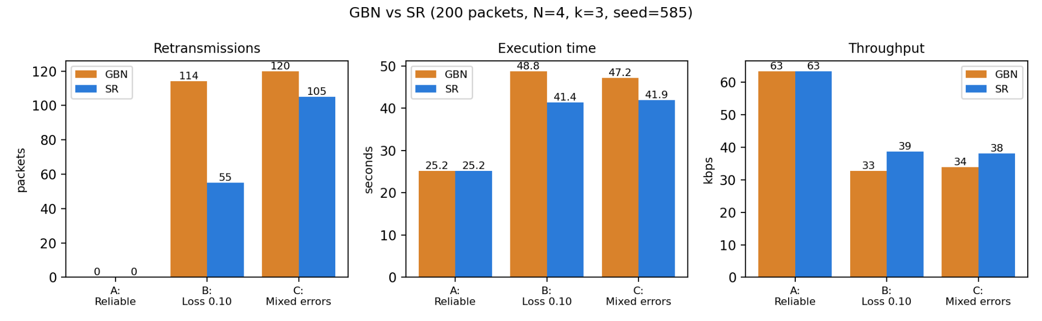
Comparison: On a reliable channel the two protocols are identical (0 retransmissions, 25.21 s). Under 10% loss GBN retransmits 114 packets against 55 for SR, because each GBN timeout resends the whole outstanding window while SR resends only the lost packet, so SR finishes about 15% sooner. With mixed errors the gap is smaller (120 vs 105) because delayed and corrupted ACKs cause timeouts in both protocols. Both protocols delivered all 200 packets correctly and in order.

5. Task 5: Transport layer analysis
1. Pipelining. L/R = 8000 / 2,000,000 = 4 ms.
- Stop-and-Wait: U = (L/R) / (RTT + L/R) = 4 / 504 = 0.00794 = 0.79% (about 15.9 kbps).
- Pipelining, N = 4: U = 4 × 4 / 504 = 16/504 = 0.0317 = 3.17% (about 63.5 kbps).
Stop-and-Wait idles for the whole 500 ms RTT after each packet. A pipelined sender keeps N packets in flight, so utilization grows N times. This matches experiment A (63.5 kbps).
2. Sequence numbers (SR, k = 3).
- (a) 2³ = 8 sequence numbers (0 to 7).
- (b) The maximum safe window is 2^{(k−1)} = 4.
- (c) With N = 5, the sender sends 0-4 and the receiver delivers them. The receiver's window moves to {5, 6, 7, 0, 1}. If all ACKs are lost, the sender times out and retransmits the old pkt 0. Seq 0 is now in the receiver's new window, so it accepts the duplicate as a new packet (#8) and the data is corrupted. With N = 4 the windows {0-3} and {4-7} never overlap, so an old retransmission is always recognised as a duplicate.

6. Conclusion
Both protocols give correct, in-order delivery over the lossy satellite link and both beat Stop-and-Wait by pipelining. SR is the better fit for this network. It retransmits fewer packets and finishes sooner once errors appear, at the cost of a receiver buffer, per-packet timers and a window limited to half the sequence space.

